Parts list:

“Of course! Here is the complete list of electronic components you'll need to build the motor controller circuit we've discussed.

## ✅ Parts List for the Motor Controller

## Semiconductors

1x IRFZ34N N-Channel MOSFET (M1)

Purpose: Acts as the high-power digital switch to turn the motor on and off.

1x 4N25 Optocoupler (U1)

Purpose: Safely isolates the Raspberry Pi from the 12V motor circuit.

1x 1N4001 Flyback Diode (or similar) (D_FLYBACK)

Purpose: Essential for protection. It safely dissipates voltage spikes from the motor when it turns off, preventing damage to the MOSFET.

## Resistors (1/4 Watt)

1x 1kΩ Resistor (R_LIMIT)

Purpose: Limits current to the optocoupler's internal LED.

1x 2kΩ Resistor (R_PULLDOWN)

Purpose: Ensures the MOSFET gate is pulled firmly to ground for a reliable "off" state.

1x 10kΩ Resistor (R_PULLUP)

Purpose: Pulls the MOSFET gate high to turn it "on" when the optocoupler is inactive.

## Main Components & Load

1x Raspberry Pi 4

Purpose: The controller that generates the PWM signal.

1x 12V DC Motor

Purpose: The device you are controlling.

## Power Supplies ⚡️

1x 12V DC Power Supply

Purpose: Provides power for the motor. The amperage rating should be sufficient for your motor's needs.

1x 5V USB-C Power Supply

Purpose: Powers the Raspberry Pi.

## Prototyping & Wiring

1x Solderless Breadboard

Purpose: To build and test the circuit without soldering.

1x Set of Jumper Wires

Purpose: To make all the connections on the breadboard.”

Build Instructions:

“Of course! Here are the detailed, step-by-step instructions to assemble your motor controller circuit on a breadboard.

Safety First! ⚠️ Before you begin, make sure all power sources are completely disconnected. Don't plug in the Raspberry Pi or the 12V power supply until the very last step.

## 1. Preparation & Breadboard Basics

Gather your components: the breadboard, IRFZ34N MOSFET, 4N25 optocoupler, resistors (1kΩ, 2kΩ, 10kΩ), the flyback diode (a 1N4001 is perfect), your 12V motor, and jumper wires.

A breadboard lets you build circuits without soldering. The holes are connected internally in a specific way:

Power Rails: The long vertical columns on the sides (marked with + and -) are connected all the way down. You'll use these for 12V power and Ground.

Terminal Strips: The shorter horizontal rows in the middle are connected across. The gap in the center (the ravine) breaks the connection, allowing you to plug in chips.

## 2. Place the Main Components

Placing the main components first gives you a clear layout to work from.

Place the 4N25 Optocoupler: Gently press the 4N25 chip into the breadboard so it straddles the center ravine. Make sure the small dot or notch on the chip is on your left. This dot marks pin 1.

Place the IRFZ34N MOSFET: Place the MOSFET somewhere on the right side of the board with its flat, labeled face towards you. The pins are spread out, so each one should be in its own 5-hole row.

Pin 1 (left): Gate (the control pin)

Pin 2 (middle): Drain (connects to the motor)

Pin 3 (right): Source (connects to ground)

## 3. Assemble the 12V Power Circuit

This is the "muscle" part of the circuit. Let's use the breadboard's red + rail for your 12V supply and the blue - rail for its ground.

Connect MOSFET to Ground: Use a short jumper wire to connect the MOSFET's Source pin (pin 3) to the blue - ground rail.

Connect Motor and Diode:

Take the flyback diode. Connect its anode (the non-striped end) to the same row as the MOSFET's Drain pin (pin 2).

Connect the diode's cathode (the striped end) to the red + power rail.

Connect the two wires from your 12V DC motor to the same two points: the motor's positive wire to the red + rail, and the motor's negative wire to the MOSFET's Drain pin (pin 2). The motor and diode should now be in parallel.

Connect Gate Resistors:

Pull-up Resistor (10kΩ): Connect one leg of the 10kΩ resistor to the red + rail (12V) and the other leg to the row of the MOSFET's Gate pin (pin 1).

Pull-down Resistor (2kΩ): Connect one leg of the 2kΩ resistor to the row of the MOSFET's Gate pin (pin 1) and the other leg to the blue - ground rail.

## 4. Assemble the 3.3V Control Circuit

This is the connection between the Pi and the optocoupler.

Connect Optocoupler Output:

Connect a wire from pin 5 of the 4N25 (the collector, bottom left) to the MOSFET's Gate pin (pin 1).

Connect a wire from pin 4 of the 4N25 (the emitter, middle bottom) to the blue - ground rail.

Connect Optocoupler Input:

Take the 1kΩ resistor. Connect one leg to pin 1 of the 4N25 (the anode, top left).

Leave the other leg of the resistor in an empty row. This will be the connection point for your Pi's GPIO signal.

Connect a wire from pin 2 of the 4N25 (the cathode, middle top) to an empty row. This will connect to the Pi's ground.

## 5. Final Connections & Power Up 🔌

This is the final and most critical step. Double-check all your wiring before proceeding.

Create a Common Ground: This is essential! Use one jumper wire to connect the blue - rail of your breadboard to one of the GND pins on your Raspberry Pi.

Connect the Pi's Control Wires:

Connect a jumper wire from the chosen GPIO pin on your Pi to the open leg of the 1kΩ resistor on your breadboard.

Connect a jumper wire from another GND pin on your Pi to the wire coming from pin 2 of the 4N25.

Connect Power (IN THIS ORDER):

First, connect your 12V power supply to the breadboard. The positive lead goes to the red + rail, and the negative/ground lead goes to the blue - rail.

Last, plug in the USB-C power supply to turn on your Raspberry Pi.

Your circuit is now fully assembled and ready for you to run your control script! 🎉”

Schematic and Description:

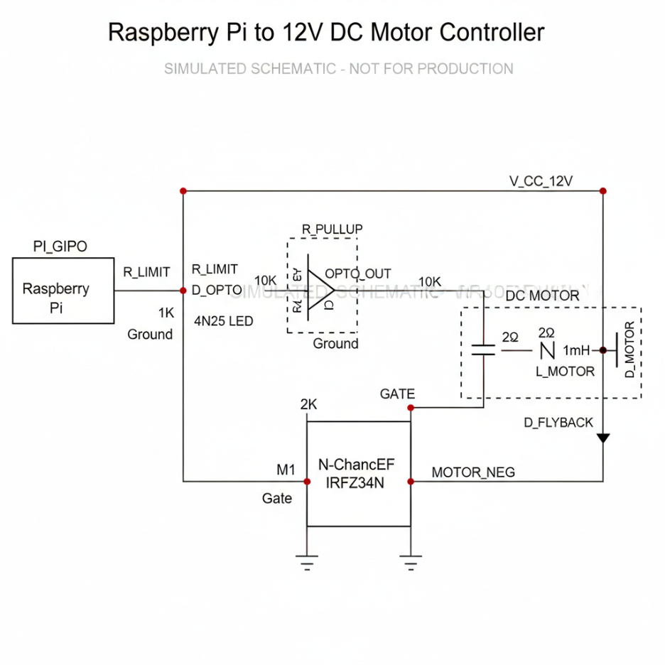

“Of course. Here is a detailed explanation of each part of that motor controller schematic, following the signal path from the Raspberry Pi to the motor.

1. Control Signal (Raspberry Pi) PI_GIPO (Raspberry Pi): This block represents the Raspberry Pi's GPIO pin. It's the "brain" of the operation, generating a 3.3V Pulse Width Modulation (PWM) signal to control the motor's speed.

R_LIMIT (1kΩ Resistor): This is a current-limiting resistor. Its only job is to protect both the Raspberry Pi and the optocoupler. It ensures the GPIO pin doesn't send too much current into the optocoupler's internal LED, which could damage both components.

1. Isolation Stage (The Safety Barrier) 4N25 LED (Optocoupler): This block represents the 4N25 optocoupler, which electrically isolates the sensitive Raspberry Pi from the high-power motor circuit. It works like a remote control using light.

D_OPTO (Internal LED): When the Pi sends a HIGH (3.3V) signal, current flows through R_LIMIT and lights up this internal, invisible infrared LED.

OPTO_OUT (Internal Phototransistor): This light-sensitive transistor detects the light from D_OPTO. When it sees the light, it switches on, allowing current to flow through it to ground. This is the key to the isolation—the signal is passed by light, not electricity.

R_PULLUP (10kΩ Resistor): This is a pull-up resistor. It's connected to the 12V supply and the MOSFET's gate. Its job is to pull the gate voltage HIGH (towards 12V) when the optocoupler is off.

Logic Note: This setup creates "active-low" logic.

Pi sends LOW (0V): The opto-LED is off, the phototransistor is off, and R_PULLUP pulls the MOSFET gate HIGH. Motor turns ON.

Pi sends HIGH (3.3V): The opto-LED is on, the phototransistor turns on and pulls the MOSFET gate LOW. Motor turns OFF.

1. Power Stage (The Muscle) M1 (IRFZ34N N-Channel MOSFET): This is the main power switch. It's a powerful transistor designed to handle the high current the motor needs.

Gate: This is the "control knob." When the voltage here is high (pulled up by R_PULLUP), the MOSFET switches on. When the voltage is low (pulled down by the optocoupler), it switches off.

Drain & Source: When the MOSFET is on, it creates a path for current to flow from the Drain (connected to the motor) to the Source (connected to ground), completing the motor's circuit.

2K Resistor (Pull-down): This resistor ensures the MOSFET's gate is pulled firmly to ground when the optocoupler is active, guaranteeing a fast and complete turn-off. It prevents the gate from "floating" in an uncertain state.

DC MOTOR (The Load): This represents your 12V motor, which is modeled with its internal resistance and inductance.

D_FLYBACK (Flyback Diode): This diode is critical for protection. When the motor is suddenly turned off, its collapsing magnetic field creates a large, damaging voltage spike. This diode gives that spike a safe, short-circuited path to flow through and dissipate, protecting the MOSFET from being destroyed.

V_CC_12V: This is the external 12-volt power supply that provides all the power for the motor itself. It is separate from the Raspberry Pi's power supply.”